LeetCode Program 2652
Link :- https://leetcode.com/problems/sum-multiples/

Successful Submission
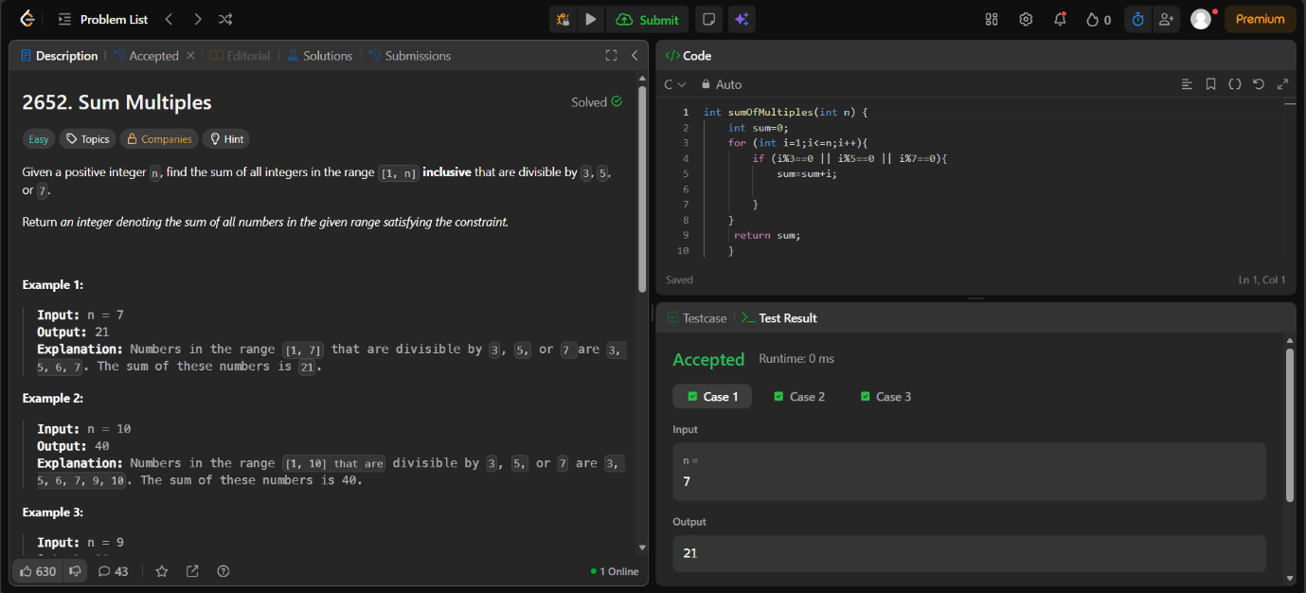
Source Code


